The Triangle
A Balanced Life
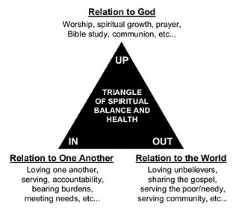
The triangle brings together three directions – UP, IN, and OUT – as a short hand for three types of relationships. A disciple strives for a balanced life, giving attention in all three directions and seeking continual growth.
This is how we express it in the terms of the St. John’s vision statement:
Up: Growing intimacy with Jesus Christ
- Knowing God more deeply through His Word, Worship, and Prayer
- Serving God as we use His gifts to His glory
In: Growing community with His followers
- Connecting to one another in meaningful relationships
- Loving one another by providing care, encouragement, and accountability
Out: Growing priestly relationships with the people of the World
- Serving the real needs of people in our community
- Sharing the life-giving Gospel of Jesus Christ with those who don’t know Him
- Supporting the growth of the Kingdom of God throughout the world
But when we are talking personal discipleship, we seek to apply the triangle to our individual lives. We’re not just talking about church programs and activities, but rather my daily life.
Here are some questions to help us evaluate how we are doing in terms of the triangle:
UP
How is my worship life?
Am I making enough space for prayer?
Am I listening for God’s leading?
Am I obedient to God’s prompting?
Am I experiencing His peace?
Am I growing closer to Christ?
Am I living in the power of the Spirit?
Am I committed to daily time with my Savior?

IN
Do I love my family?
Do I love my colleagues?
How are my relationships with my friends?
Do I keep my promises?
Am I investing in the relationships that are most important to me?
Are there family/relationship issues that I’m avoiding dealing with?

OUT
Do I have a heart for non-Christians?
How often do I share my faith?
Do I leave time for relationships with non-Christians?
Am I proud of the Gospel or ashamed?
Am I a servant?
Am I seeking to be a blessing?
So the triangle reminds us and encourages us to grow in a balanced way, giving attention to all three directions.

