Invitation and Challenge

Invitation and challenge are important concepts in discipleship. We see this rhythm in the ministry of Jesus in working with his disciples. Invitation refers to welcoming grace, and challenge refers to either rebuking or pushing to move forward.

Invitation | Challenge
“Come follow me.” | “Go and make disciples.”
Jesus’ words to Peter after his confession of faith in Matthew 16:17-19 | Jesus’ rebuke of Peter in Matthew 16: 23
²⁸ “Come to me, all you who are weary and burdened, and I will give you rest. ²⁹ Take my yoke upon you and learn from me, for I am gentle and humble in heart, and you will find rest for your souls. ³⁰ For my yoke is easy and my burden is light.” (Matthew 11:28-30) | “If anyone would come after me, he must deny himself and take up his cross and follow me.  (Matthew 16:23)

Discipleship requires a healthy balance of high invitation and high challenge. The goal of a discipling huddle is to provide that balance, so that we will be appropriately challenged on the journey of growth. We want to grow as disciples, rather than remain in cozy comfort.

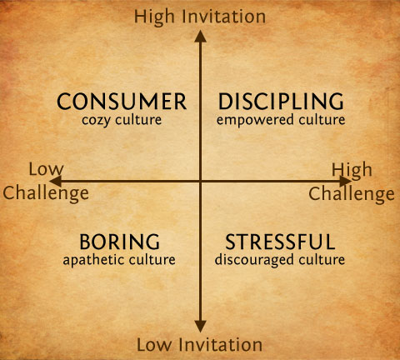

The concept of invitation and challenge is depicted in the “Horse Whisperer” Monty Roberts way of working with horses: http://www.youtube.com/watch?v=9Dx91mH2voo

