The Hexagon: Prayer
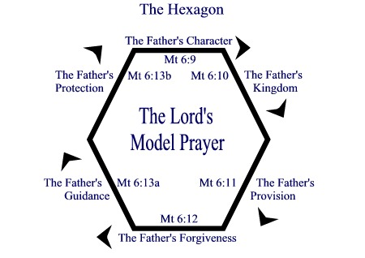
How are we to pray? We don’t have to be in the dark regarding this important question. Jesus provided His disciples with the answer. We call in the “Lord’s Prayer” or the “Our Father.” But too often we see this as only a prayer to be prayed, rather than opening it up more fully as a pattern or template for prayer. In giving us this prayer, Jesus surely intended for it to be a list of specific prayer needs or topics that we are to keep in mind as we pray.
The Hexagon is a simple shape to remind us of the parts of the Lord’s Prayer. As we go around the hexagon, we pray regarding the topic that Jesus gave us.
The Father’s Character (Our Father who art in heaven, hallowed be your name): We focus on God’s name, that is, His character and reputation. Our prayer begins with praise, honoring God for being our father. We seek to life up his name in all that we do.
The Father’s Kingdom (Thy kingdom come, Thy will be done earth on as it is in heaven): We pray for His kingdom and His will, not our own. This is about acknowledging his rule and reign in our lives, and surrendering our will before Him. It is so vital before presenting our wants to the Lord that we surrender our wills.
The Father’s Provision (Give us this day our daily bread): God provides for all our needs, and not only for ours, but for all, no matter how worthy or unworthy. We pray that we might be reminded of this, and turn to the Lord in thanksgiving.
The Father’s Forgiveness (Forgive us our trespasses, as we forgive those who trespass against us): We pray for the Father’s forgiveness, but also for hearts that are willing to forgive those who have sinned against us. We seek to be channels of God’s mercy, representatives of His kingdom, as His forgiving grace flows to us and through us.
The Father’s Guidance (And lead us not into temptation): We pray that the Father lead us away from harmful paths. Although this petition is stated negatively, we can also pray it positively as a prayer for divine guidance. We pray that God guide us in right ways, according to His will.
The Father’s Protection (but deliver us from evil): We are engaged in spiritual warfare. We live in a fallen world. There is evil around us, and an evil one opposed to us. We pray for the Father’s protection in the face of all evil, physical and spiritual.
This is a pattern for prayer, not only regarding prayer for ourselves, but also prayer for others. In fact, any need or situation that requires prayer can be prayer through using the hexagon. Try it. Daily. For this is how our Lord taught His disciples to pray.

