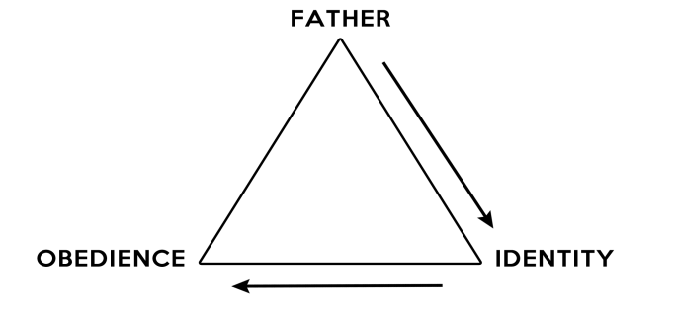
Covenant and Kingdom
This big picture of Scripture is Covenant and Kingdom. What do we mean by this?

Covenant is about identity. We are the beloved children of the Father, declared to be his own in our baptism, and confirmed by His grace each day of our lives. This is our identity. We live out this identity through obedience to our loving Father.

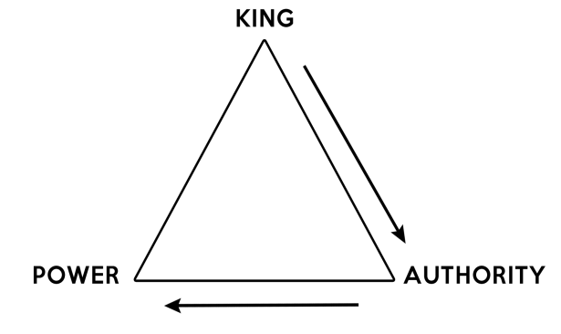

Kingdom is about responsibility. God is not only Father; he is King of all creation. He has called us to represent Him in the world, sending us out with His authority. When we go forth in His authority, we are accompanied by His power.

